CHAPTER – 3

DESIGN & MODELING

#### Activity Diagram

#### Usecase Diagram

* 1. **Activity diagram**

The activity diagram represents the flow of activity in terms of behavior and designing an activity diagram helps the development team to recognize when the activity starts, which activity starts and when it gets terminated.

* Activity Diagram of Water supply system

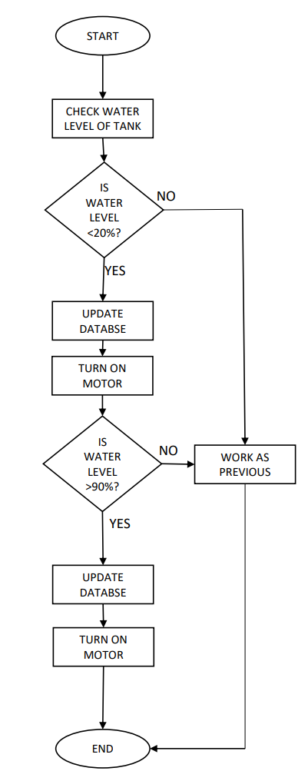

* Activity Diagram of Parking System

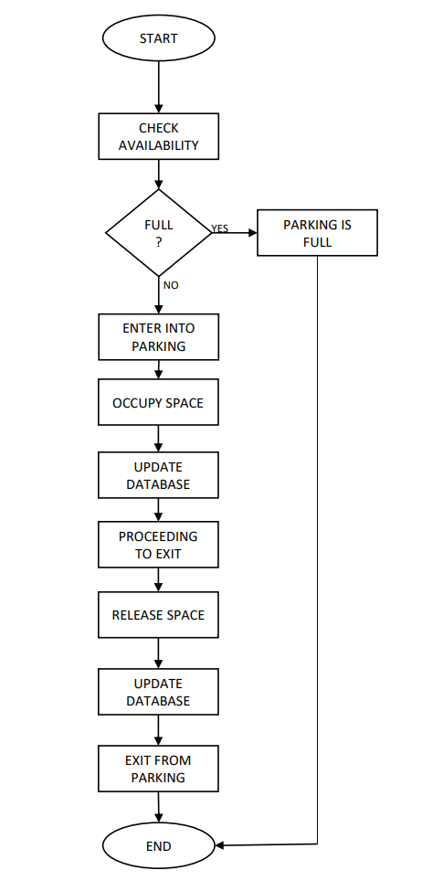

#### Usecase diagram

#### The us case diagram is an UML diagram which represents the modules as actors of the system and their attachments which the use cases define in the system box.

* Usecase diagram of waste management system

